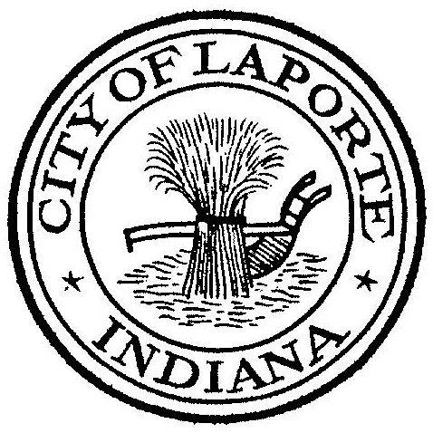
Board of Public Works and Safety
Jessica Romine, Member Tom Dermody, Mayor Mark Kosior, Member
City Hall 801 Michigan Ave., La Porte, IN 46350
Tuesday, April 18, 2023
9:00 AM
AGENDA
- Call To Order
- Pledge Of Allegiance
- Approval Of Minutes
- Public Comment: In Person and via Facebook Live
- Clerk-Treasurer: Claims Approval
- Department Head Reports
- New Business:
-CVB Civic Director Agreement 2023
-Andy Snyder: Child Passenger Safety Grant
-Paul Brettin: SAVE Grant
Permission to hire
-Mary Ann Richards: Home Owner Repair Program Quotes
-Jerry Jackson: Phosphorus Pay Request #12
-Andrea Smith: New Position Job Description-Property and Evidence Technician
-Nick Minich: VOIP System Quote
8) Unfinished Business:
9) Other Business: Next regularly scheduled meeting: Wednesday, May 3, 2023 at 9a due to
Election Day.
10) Adjourn

